Readiness Assessment Framework
2022
This framework was developed by The Health Policy Partnership
Contents
Health system readiness 3
Using the Readiness Assessment Framework 4
Readiness Assessment Framework 7
1 Governance 7
2 Regulation and reimbursement 7
3 Identified need 8
4 Service provision 9
5 Health information 10
References 11

Health system readiness
Events in the past decade have highlighted the need to create health systems that are ready to adapt to both expected and unexpected changes. Among policymakers, there is a push to build health system resilience,¹ ² whereby we plan for, learn from and minimise disruption caused by sudden events such as pandemics, wars or environmental crises.³ ⁴ There is also acknowledgement of the need to strengthen health systems’ capacity, to enable continued provision of core services⁵ as populations age and rates of non-communicable diseases such as cancer⁶ and diabetes⁷ are on the increase. Intrinsic to achieving both of these ambitions is the need to be ready to appropriately integrate components of care that enable more efficient, effective and equitable health management (Box 1).
Box 1. What do we mean by integration of and readiness for components of care?
Components of care can refer to diagnostics or treatments that have the potential to significantly improve patient care. The term can also refer to monitoring systems that enable better assessment of outcomes.
Integration is the adoption and assimilation of a component of care into every aspect of a health system (i.e. governance, regulation, workforce, reimbursement and service delivery frameworks) in order to ensure its availability to all people who may benefit from it.
Readiness is the ability of a health system to rapidly and sustainably adapt policies, processes and infrastructure to support integration of a component of care.
By fostering health system readiness, we are strengthening our health systems to ensure they can improve population health, as per the UN Sustainable Development Goals.⁸ Timely and equitable integration of components of care means that all people have access to the most appropriate care, have improved outcomes, and can ultimately lead healthier lives. But integrating components of care can be time consuming and resource-intensive⁹ as it may require new or adapted infrastructure, staff training or delivery methods. Proactive system-level planning is essential to overcome these challenges, optimise efficiency and maintain sustainable delivery of care.
Planning for readiness requires a systems approach. This implies conducting a detailed assessment and information-gathering exercise to assess what is needed across the entire health system, to ensure appropriate integration of the care component of interest. This analysis is essential to understand the complexities and nuances that may impede complete integration of a component of care; it needs to be context-specific, and data must be collected with the end use in mind, and with multi-sectoral involvement.
Our work on radioligand therapy has demonstrated the value of this approach. We developed the Radioligand Therapy Readiness Assessment Framework¹⁰ to evaluate current readiness for integration of new and existing radioligand therapies into care. We adapted this framework and applied it in the UK¹¹ and US¹², and used this research to generate a series of policy actions specific to each country.¹³ ¹⁴ We also looked at other existing frameworks to asses what lessons could be learnt from their application – and how such frameworks could best be used to encourage a data-driven approach to health planning,¹⁵ regardless of the component of care being assessed.

Using the Readiness Assessment Framework
The Readiness Assessment Framework provides a generic structure for evaluating the current state of readiness to integrate a component of care. It is derived from the Radioligand Therapy Readiness Assessment Framework, but offers a generic template that can be modified or adapted to ensure the smooth integration of a component of care across five domains of a health system: governance, regulation and reimbursement, identified need, service provision, and health information (Figure 1).
The framework includes top-line questions, or indicators, for each domain and subdomain of a health system. These questions are most suited to assess system readiness for the integration of diagnostics, treatments or monitoring systems, and will require further refinement to ensure the framework addresses the specificities and nuances of the component of care in question. Regardless of the component of care being assessed, the whole care pathway needs to be considered, with framework questions tailored to the unique requirements and context of the area of interest. Please note that, at this stage, this framework is not designed to be used to consider readiness for public health efforts or broader health strategies.

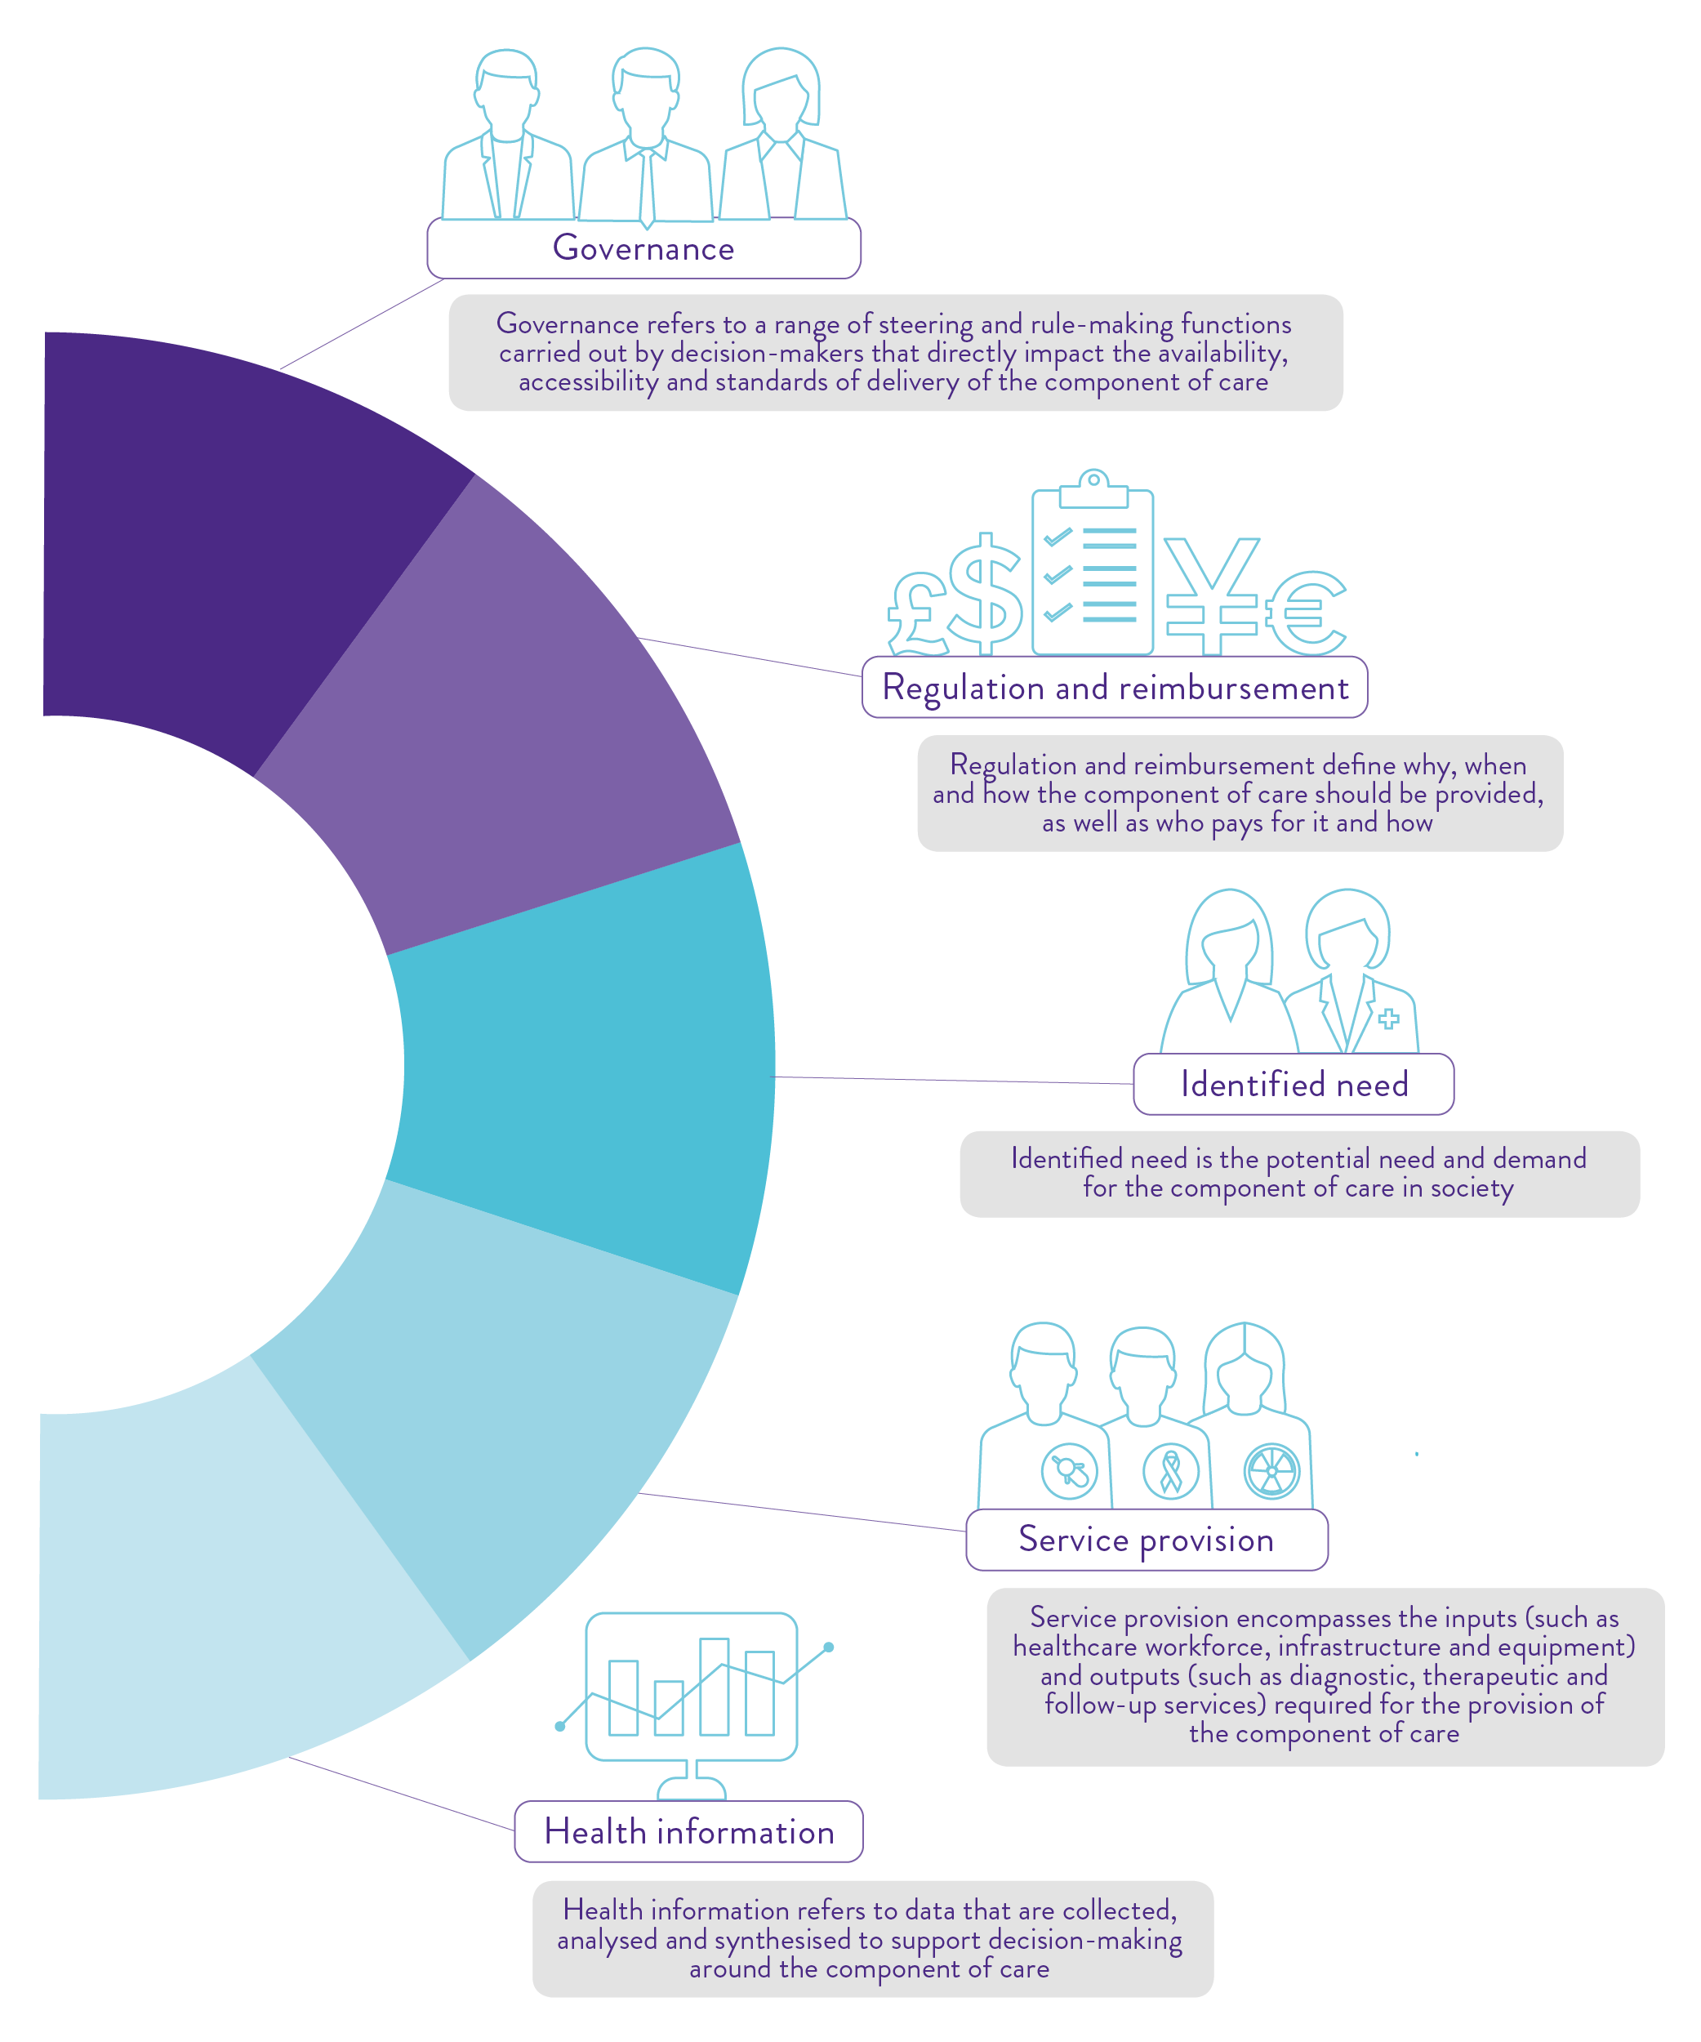
Figure 1. A systems approach to readiness for a component of care

We hope this framework is a useful tool for researchers, clinicians and patient advocates to encourage evidence-based planning for health system readiness. Frameworks enable the generation of consistent data across different contexts, facilitating individual understanding and sharing of learnings.¹⁵ We hope that this framework can contribute to a shared vision of what health system readiness should entail as we look to improve our health systems and advance care in different areas.
We encourage interested parties to adapt and apply this framework to their own settings or areas of interest. We have developed a masterclass video, which outlines a standardised approach to applying the framework. The Health Policy Partnership would also be very interested in exploring opportunities to apply the framework to new areas; please contact us if you would like to discuss any ideas for its application at healthsystemreadiness@hpolicy.com.

Readiness Assessment Framework

Governance
Leadership and planning
- Is there a national/regional health strategy or plan that appropriately includes, or could include, the component of care?
- To what extent do these national/regional health strategies or plans influence clinical care and service delivery?
- Are there national/regional disease-specific strategies or plans that appropriately include, or could include, the component of care?
- To what extent do these national/regional disease-specific strategies or plans influence disease management?
- Is there national leadership and political support for integration of the component of care?
Guidelines and best practice
- Do relevant disease-specific clinical guidelines consistently and appropriately include the component of care?
- Do these, or other widely accepted guidelines, include information on how to deliver the component of care?

Regulation and reimbursement
Regulation
- Are regulatory approval processes well suited, or easily adapted, to the component of care and any associated diagnostics, treatments or monitoring that are integral to its delivery?
- Are existing regulatory evidence requirements applicable to and appropriate for the component of care and any associated diagnostics, treatments or monitoring that are integral to its delivery?
- Are regulations for the production, supply and disposal of materials used in the component of care appropriate?
- Are regulations for the administration of the component of care appropriate and conducive to safe, effective and streamlined delivery?
Reimbursement and funding
- How is the component of care funded? If it is not currently funded, is it clear how it will be funded?
- Are existing reimbursement and funding mechanisms appropriate for the component of care and any associated diagnostics, treatments or monitoring that are integral to its delivery?
- Are existing reimbursement/health technology assessment evidence requirements applicable to and appropriate for the component of care and any associated diagnostics, treatments or monitoring that are integral to its delivery?

Identified need
Epidemiology
- What is the current burden of disease where the component of care would be used?
- Are there any trends in population health, disease incidence or severity that may impact the burden of disease where the component of care would be used?
- Would appropriate integration of the component of care significantly impact demand for other services along the care pathway?
Patient awareness and information
- Is appropriate information about the component of care readily available for people who may benefit from it?
Healthcare professional awareness and referral patterns
- Are relevant healthcare professionals aware of the component of care and its role within the care pathway?
- Is the component of care included to an appropriate level in training for relevant healthcare professionals?
- What are the barriers and facilitators to optimal referral for appropriate delivery of the component of care?
- Are people who might benefit from the component of care able to access it, as well as any associated diagnostics, treatments or monitoring that are integral to its delivery? Are there any known inequities in access or outcomes?

Service provision
Workforce capacity
- Which healthcare professionals are or should be involved in providing the component of care?
- Is there sufficient workforce capacity to meet current and projected future demand for the component of care?
- What form does communication and interaction between all relevant healthcare professionals take?
Health facility capacity
- Is the delivery of this component of care appropriately and equitably organised?
- Are there sufficient facilities to safely and effectively meet current and future demand for the component of care?
- What impact might appropriate integration and use of this component of care have on demand for associated diagnostics, treatments or monitoring that are integral to its delivery?
- Is there sufficient capacity in the rest of the care pathway to meet current and future demand for the component of care and associated diagnostics, treatments or monitoring that are integral to its delivery?

Health information
Research and data
- Is there sufficient data collection on the component of care to guide future planning and practice? Consider:
- data from clinical trials
- real-world data on effectiveness in clinical practice
- registry and audit data
- economic data.
- Do current data collection methods appropriately capture the efficacy and safety of the component of care?
- Is data collection efficiently organised, and conducted with appropriate frequency and repeatability?
- How is evidence incorporated into health system planning?
Patient-generated data
- Are there sufficient data collected about the patient experience of using or receiving the component of care?
- Are there appropriate patient-reported outcomes to measure the efficacy and safety of the component of care?
- Is planning for delivery of the component of care completed with input from people who might benefit from it?

References
1. Peytremann B, Camille P, Valery R, et al. 2021. A health systems resilience research agenda: moving from concept to practice. BMJ Global Health 6(8): 1-5
2. The Lancet. 2021. Rebuilding resilient health systems for Europe. The Lancet Regional Health – Europe: 10.1016/j.lanepe.2021.100238
3. Thomas S, Sagan A, Larkin J, et al. 2020. Strengthening health system resilience: key concepts and strategies. Copenhagen: World Health Organization
4. The Organisation for Economic Co-operation and Development. 2020. Health at a Glance Europe 2020: State of Health in the EU Cycle. Paris: The Organisation for Economic Co-operation and Development
5. Finn M, Gilmore B, Sheaf G, et al. 2021. What do we mean by individual capacity strengthening for primary health care in low- and middle-income countries? A systematic scoping review to improve conceptual clarity. Human Resources for Health 19(1): 1-13
6. International Agency for Research on Cancer. Estimated number of new cases from 2020 to 2040, Both sexes, age [0-85+]: All cancers. Available from: https://gco.iarc.fr/tomorrow/en/dataviz/bars?mode=population [Accessed 12/07/21]
7. World Health Organization. 2021. Diabetes - factsheet. Available from: https://www.who.int/news-room/fact-sheets/detail/diabetes#:~:text=Key%20facts,stroke%20and%20lower%20limb%20amputation. [Accessed 26/04/22]
8. United Nations. 2021. Goal 3: Ensure healthy lives and promote well being for all at all ages. [Updated 2021]. Available from: https://sdgs.un.org/goals/goal3 [Accessed 24/05/2022]
9. The Organisation for Economic Co-operation and Development. 2015. Fiscal Sustainability of Health Systems. Paris: The Organisation for Economic Co-operation and Development
10. The Health Policy Partnership. 2021. Radioligand therapy readiness assessment framework. London: HPP
11. The Health Policy Partnership. 2021. Health system readiness for radioligand therapy in the UK: Situation analysis report. London: HPP
12. The Health Policy Partnership. 2021. Health system readiness for radioligand therapy in the US: Situation analysis report. London: HPP
13. The Health Policy Partnership. 2021. Creating a ready health system for radioligand therapy in the UK: Policy action blueprint. London: HPP
14. The Health Policy Partnership. 2021. Creating a ready health system for radioligand therapy in the US: Policy action blueprint. London: HPP
15. The Health Policy Partnership. 2021. Fostering system readiness in cancer care. London: HPP

About The Health Policy Partnership
The Health Policy Partnership (HPP) is an independent research organisation, working with partners across the health spectrum to drive the policy and system changes that will improve people’s health.
Please cite this framework as: The Health Policy Partnership. 2022. Readiness assessment framework. London: The Health Policy Partnership.

Contact information
The Health Policy Partnership Ltd
68–69 St Martin’s Lane
London WC2N 4JS
United Kingdom

For more information, please see www.healthsystemreadiness.com or contact Lucy Morgan at The Health Policy Partnership: Lucy.Morgan@hpolicy.com

© 2022 The Health Policy Partnership. The authors do not permit modification of pages
1–6 of this document. The Readiness Assessment Framework is licensed under the Creative Commons Attribution-ShareAlike 4.0 International (CC BY-SA 4.0) Licence. To view a copy of this licence, visit https://creativecommons.org/licenses/by-sa/4.0/

